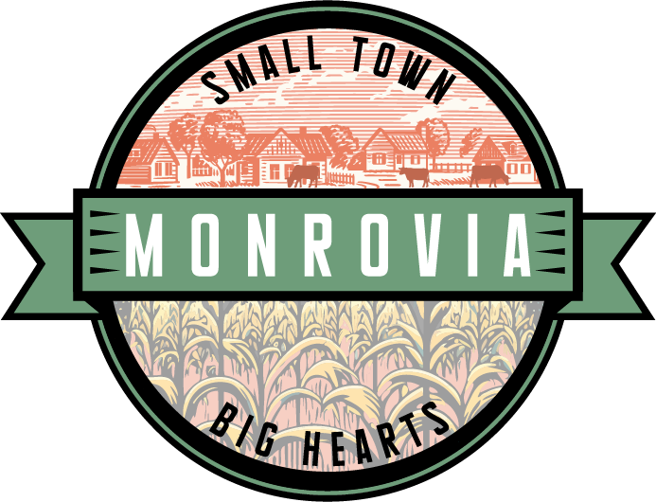
AGENDA
Monrovia Town Council Meeting April 25, 2023, 6:30 pm
140 E. Main Street Monrovia, Indiana 46157

Pledge / Invocation / Roll Call Minutes: March 28th Council Meeting
Bank Reconciliation & Voucher/Claims Packet: March Bank Reconciliation / April Claims Packet

Public Comment:
- For items not on the agenda (please limit to 3 minutes each)

Public Hearing: 2nd public meeting regarding converting Water Street (N. of SR 42) to a one- way street travelling North.

Old Business:
- Permit Requirement – 155 E. Main Street
- Town Logo – Final Council Approval.
- 90-Day Notice – Current Town Hall
- Proposed Crosswalks

New Business:
- Consider Ordinance to Establish the Position of Town Manager
- Consider Amendment to Fair Housing Ordinance
- Consider Draft Noise Ordinance
- Consider Change in Officer Employment Status

Police:
- Department Update

Plan Commission / BZA:
- Minutes from most recent meeting(s)

Sewer:
- Department Update
- New Blower - Update
- Capacity Fee Payment Analysis – Update from HCRSD & Next Steps

Public Works:
- Committee Chairman Update to Council
- CCMG Project – Awarded Bid
- MCRW – Annual Meeting: June 8, 2023.

Parks & Recreation:
- Minutes from Most Recent Meeting
- Board Update

Council Comment & Additional Topics:
- Redevelopment Commission – Determining Members
- Citizen Inquiry – Retaining Wall between back of properties and Section 8 homes in Homestead Subdivision
- Flyer – New Govt. Center Grand Opening – May 13th.

Adjourn

Next Regular Scheduled Meeting: May 23, 2023

Agenda Subject to Change

